

JOB DESCRIPTION

Job title: Support Worker - Access to Work

Hours: 10 hours per week (across Tuesday and Wednesday)
Bank contract

Salary: Point 17/Business Support pay scale: £12.71 per hour

Closing Date: 28 November 2026 at 5 pm

Job purpose:
To support the Braille Transcription Operative with the visual aspects of their work, the work will be varied.

Main duties and responsibilities:

- Reading through documentation
- Support with Databridge input
- Describing layout of documentation if more complex, for example tables.
- Ensuring that visual appearance of documents is as expected
- Supporting to access systems that are not easily accessible
- Support to access and transcribe visual information such as pictures and diagrams.
- Converting and finding information in PDF or other electronic documents that are not accessible.
- Orientation, and support with visual elements of my teaching Not applicable.
- Entering student progress information onto the system not applicable.
- Completing paperwork that cannot be done electronically.

Note: This job description covers the main, current duties and responsibilities of the job; however, it is subject to review and amendment in the light of developing or changing organisational needs. Other activities commensurate with this Job Description may from time to time be undertaken by the Job Holder.



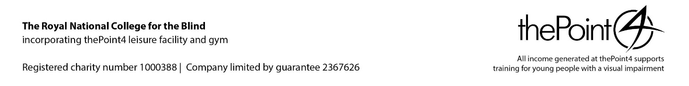

PERSON SPECIFICATION – Support Worker – Access to Work
Essential and Desirable criteria will be assessed using a range of methods that may include: application form, interview, task or test, presentation of certificates or required document. Consideration will be given to candidates who may not hold all of the essential requirements but who can demonstrate equivalent and relevant experience.

ATTRIBUTES | ESSENTIAL | DESIRABLE
Experience | - Proof reading skills  - Ability to access information online | - Ability to use Databridge
Knowledge/skills | - Awareness of IT Document presentation  - Good knowledge of Word. | - Proven understanding and use of Office 365  - Ability to create accessible documents.
Qualifications and training
Aptitudes and abilities | - To be able to respond to needs  - To be able to describe visual attributes
Disposition, attitude and motivation | - Understanding of safeguarding for our students and a commitment to safe practice  - Commitment to equality and diversity and its active promotion
Additional/other | - Enhanced DBS (Disclosure & Barring Service) disclosure required prior to appointment being confirmed  - Eligibility to work in the UK

